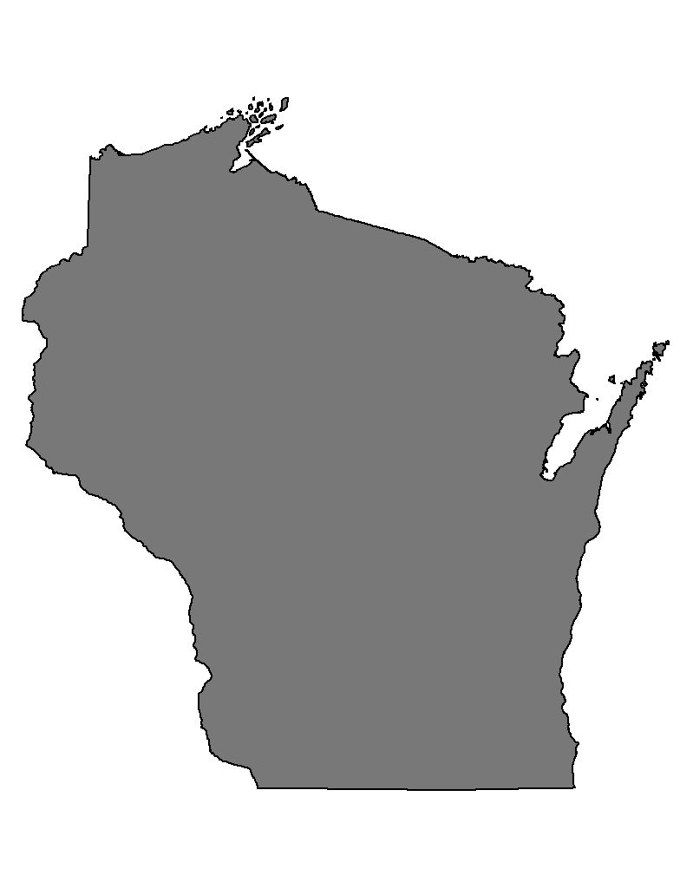
ARM-PI-414
WI PERMIT NO.

STATE OF WISCONSIN APPLICATION FOR PERMIT TO MOVE LIVE PLANT PESTS OR BIOLOGICAL CONTROL AGENTS
WISCONSIN DEPARTMENT OF AGRICULTURE, TRADE AND CONSUMER PROTECTION
DIVISION OF AGRICULTURAL RESOURCE MANAGEMENT
PLANT INDUSTRY BUREAU
2811 AGRICULTURE DRIVE P.O. BOX 8911 MADISON, WI 53708-8911 Phone: 1-800-462-2803

THIS SECTION TO BE COMPLETED BY THE APPLICANT TYPE OF ORGANISM TO BE MOVED

NAME, TITLE, AND ADDRESS  Name:  Business/Organization/Agency:  Title:  Address:  City: State: Zip Code:  TELEPHONE NUMBER ( ) |  |  | ☐ Pathogen  ☐ Insect  ☐ Biological Control Agent  ☐ Mollusk  ☐ Other
SCIENTIFIC NAMES OF PESTS TO BE MOVED | CLASSIFICATION  (Order, Family, Race  Race or Strain) | LIFE  STAGE | NO. OF  SPECIMENS OR UNITS |  | SHIPPED FROM  (Country or State) |  |  | ARE PESTS  ESTABLISHED  IN WI? | MAJOR HOST(S) OF THE PEST
1.

2.

3.

4.

5.

DESTINATION COUNTY or COUNTIES | APPROXIMATE NUMBER OF RELEASES AND SITES |  |  |  |  | ESTIMATED DATE OF ARRIVAL OR INTERSTATE MOVEMENT
SUPPLIER (include address) | NUMBER OF SHIPMENTS |  |  |  |  | METHOD OF SHIPMENT  ☐ Air Mail ☐ Air Freight ☐ Baggage ☐ Auto
INTENDED USE (Please attach outline of intended research and any supporting materials)

SIGNATURE OF APPLICANT  I agree to comply with any conditions  printed on the reverse of this form. |  |  |  |  |  |  |  |  |  | DATE
SECTION TO BE COMPLETED BY STATE OFFICIAL
RECOMMENDATION INSPECTION  APPROVE YES  DISAPPROVE NO INSPECTOR NAME ____________________________________________INSPECTION DATE ___________________ |  |  |  |  |  |  |  |  |  | CONDITIONS RECOMMENDED  (See reverse side)
SIGNATURE |  |  |  | TITLE  STATE OF WISCONSIN PERMIT NUMBER |  |  |  |  |  | DATE
Permit not valid unless signed by an authorized official of the WDATCP PLANT INDUSTRY BUREAU
Under authority of the Stats. s. 94.03 (1) and (2), Wis. Stats. permission is hereby granted to the applicant named
above to move the pests described, except as deleted, subject to the conditions stated on, or attached to this application. Note: This WI permit does not take the place of PPQ Form 526 issued by the USDA APHIS, if required. Persons intending to obtain living plant pests from a county, state or province other than Wisconsin should apply for a PPQ From 526 permit at least 90 days before the expected shipment.

STATE OF WISCONSIN APPLICATION FOR PERMIT TO MOVE LIVE PLANT PESTS OR BIOLOGICAL CONTROL AGENTS
WISCONSIN DEPARTMENT OF AGRICULTURE, TRADE AND CONSUMER PROTECTION
DIVISION OF AGRICULTURAL RESOURCE MANAGEMENT
PLANT INDUSTRY BUEAU
2811 AGRICULTURE DRIVE P.O. BOX 8911 MADISON, WI 53708-8911

WHICH PERMIT DO I NEED?

ORIGIN OF PLANT PEST OR BICONTROL AGENT | FORM NEEDED
OUTSIDE OF UNITED STATES | PPQ FORM 526 & STATE OF WI APPLICATION FORM TO MOVE LIVE PLANT PESTS OR BIOCONTROL AGENTS
OUTSIDE OF WISCONSIN | PPQ FORM 526 & STATE OF WI APPLICATION FORM TO MOVE LIVE PLANT PESTS OR BIOCONTROL AGENTS
INSIDE OF WISCONSIN | STATE OF WI APPLICATION FORM TO MOVE LIVE PLANT PESTS OR BIOCONTROL AGENTS

PPQ Form 526 and other permit applications can be found at the USDA APHIS website:
http://www.aphis.usda.gov/ppq/permits

STANDARD PRECAUTIONARY MEASURES OF
STATE OF WISCONSIN APPLICATION FOR PERMIT TO MOVE
LIVE PLANT PESTS OR BIOLOGICAL CONTROL AGENTS

1. All pests must be shipped in sturdy, escape-proof containers.

2. No propagative host plant parts are to be shipped with approved organisms
unless the organisms normally live within the propagative plant part.

3. If pest is designated for laboratory use only, pests shall be kept only within the
laboratory or designated area at the permittee's address.

4. No living pests kept under this permit shall be removed from confined area
except by prior approval from WDATCP regulatory officials.

5. Without prior notice and during reasonable hours, authorized WDATCP
regulatory officials shall be allowed to inspect the conditions under which the
pests are kept or the location(s) at which the organisms are to be released.

6. All pests kept under this permit shall be destroyed at the completion of the
intended use, and not later than the expiration date, unless an extension is
granted by this issuing office.

7. All necessary precautions must be taken to prevent unintended escape of pests.
In the event of an escape, notify WI Pest Survey & Control Hotline at 1-866-440-7523.

8. Permittees moving field collected organisms must take all precautions to prevent the
spread or movement of any non-permitted organisms and/or diseased or parasitized individuals.

ADDITIONAL CONDITIONS RECOMMENDED

