ARM-PI-414
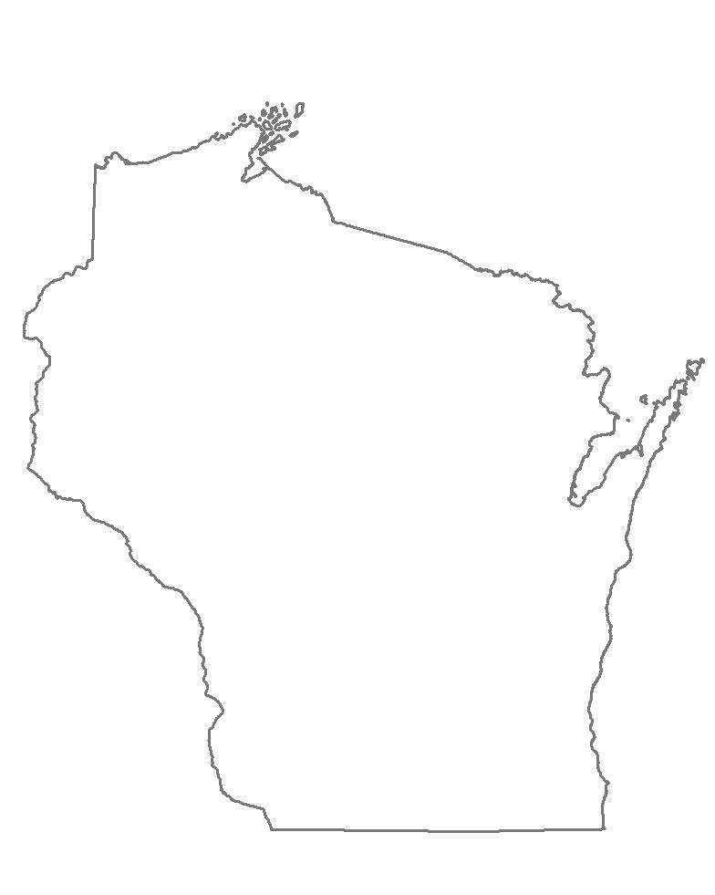

STATE OF WISCONSIN APPLICATION FOR PERMIT TO MOVE LIVE PLANT PESTS OR BIOLOGICAL CONTROL AGENTS
WISCONSIN DEPARTMENT OF AGRICULTURE, TRADE AND CONSUMER PROTECTION DIVISION OF AGRICULTURAL RESOURCE MANAGEMENT
PLANT INDUSTRY BUREAU
2811 AGRICULTURE DRIVE, P.O. BOX 8911, MADISON, WI 53708-8911 Phone 1-800-462-2803
PART II: DOCUMENTATION OF THE RELEASE OF BIOLOGICAL CONTROL AGENTS
PERMITTEE MUST COMPLETE THIS FORM AND SEND TO THE ADDRESS BELOW, EMAIL OR FAX TO (608) 224-4656 WITHIN 30 DAYS FOLLOWING THE RELEASE OF APPROVED BIOLOGICAL CONTROL AGENTS
NAME, TITLE AND ADDRESSS OF APPLICANT
APPLICANTS MUST COMPLETE THIS FORM AND EMAIL OR SEND TO THE ADDRESS BELOW WITHIN 30 DAYS FOLLOWING THE RELEASE OF APPROVED BIOLOGICAL CONTROL AGENTS
WISCONSIN DEPARTMENT OF AGRICULTURE, TRADE & CONSUMER PROTECTION - ARM
2811 AGRICULTURE DRIVE
P.O. BOX 8911
MADISON, WI 53708-8911
ATTN: SHAHLA WERNER (608) 224-4581
shahla.werner@wisconsin.gov

NAME:
TITLE:
AGENCY/BUSINESS/ORGANIZATION:
ADDRESS:
CITY: STATE: ZIP CODE:
TELEPHONE NUMBER:

SITE | COUNTY & NEAREST TOWN | TOWNSHIP | GPS COORDINATES  OR TRS | BIOCONTROL AGENT | RELEASE  DATE | NUMBER  RELEASED | SOURCE OF BIOCONTROL AGENT OR ORIGINAL COLLECTION SITE | HOST

PERMITTEE MUST COMPLETE THIS FORM AND EMAIL, SEND TO THE ABOVE ADDRESS OR FAX TO (608) 224-4656 WITHIN 30 DAYS FOLLOWING THE RELEASE OF APPROVED BIOLOGICAL CONTROL AGENTS
PLEASE ATTACH MAPS OF RELEASE SITES WHEN AVAILABLE

